Design with the Living 2021
Thursday 4th & Friday 5th November (13 – 17:30, GMT)
Online via Zoom (link sent separately)
#designwiththeliving
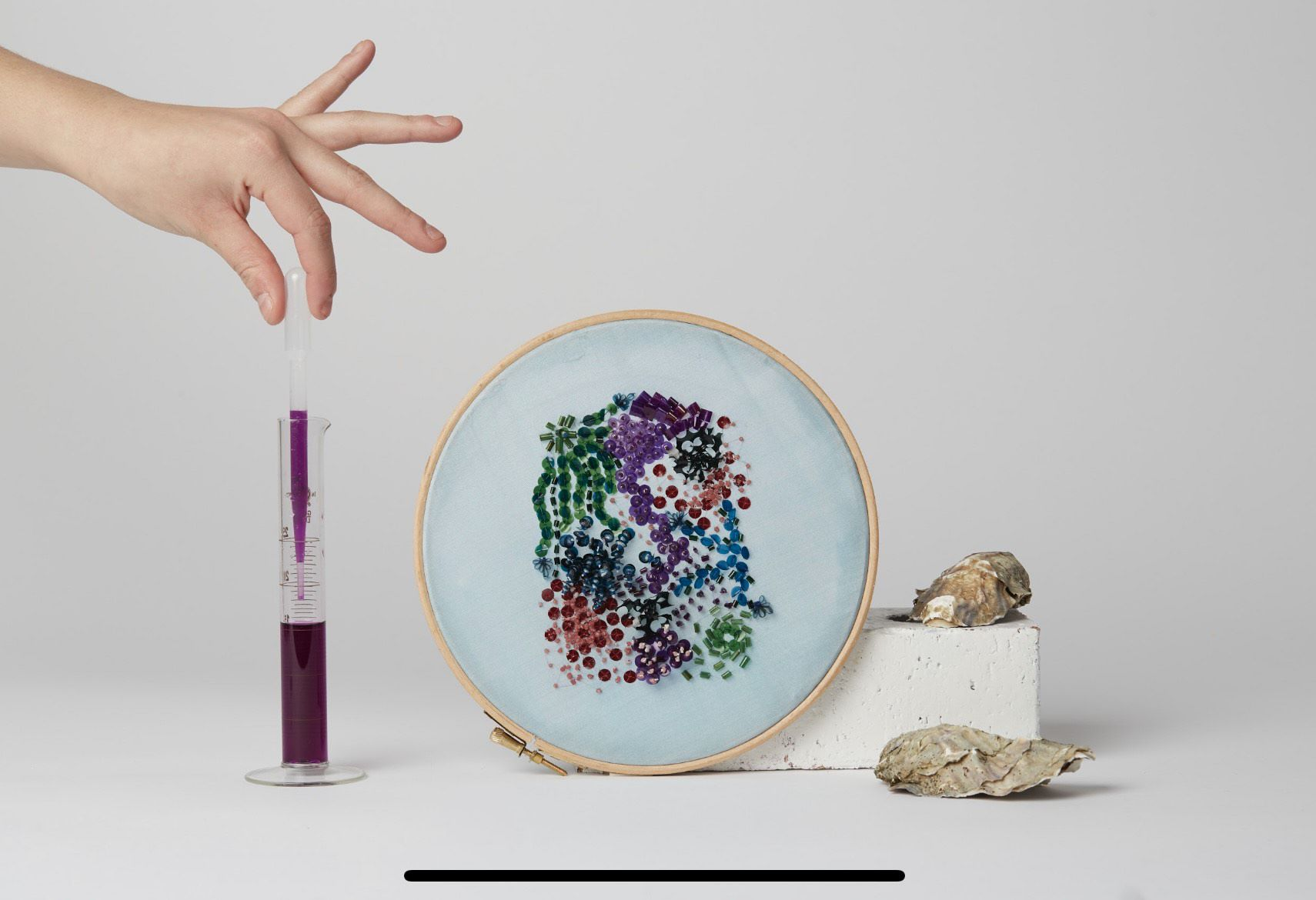
Image: Excessories by Cassie Quinn 2020, photography Paul Cochrane.
The third annual Design with the Living symposium aims to explore how a living systems thinking approach to design can nurture a radical mindset where multi-species creative collaborations can contribute to planetary heath.
This symposium aims to participate in shaping an ecological blueprint for future biodesign practice. It is co-organised by the Design Museum, the Living Systems Lab (Central Saint Martins UAL), The Bio ID Lab (Bartlett School of Architecture, UCL) and the British Council.
The event will bring together a range of perspectives from designers, scientists, researchers, ecologists, architects, and ask: is biodesign truly addressing planetary challenges, or is biodesign perpetuating a mindset of natural exploitation and business as usual? Can biodesign adopt multi-species thinking? Should this design approach become the norm?
Agenda
Day 1: Thursday 4th of November
13:00 – 13:15 Welcome and Opening Provocation from Frederic Migayrou, Chair and Bartlett Professor of Architecture at The Bartlett School of Architecture
13:15 – 15:00 PANEL 1: Biodiversity
How can designing with living systems help restore degraded ecologies and nurture biodiversity?
Chaired by Carole Collet
Harry Watkins, Director of St Andrews Botanic Garden, PhD candidate at the University of Sheffield and Lecturer at UCL.
Laura Drouet and Olivier Lacrout, Curators and Founders of Studio d-o-t-s.
Brigitte Kock and Irene Roca Moracia, Designers, Maison/0, Central Saint Martins UAL
Miriam Josi and Stella Lee Prowse, Designers and winners of the Boisbuchet Residency Awards 2021
15:00 -15:15 Break
15:15 - 17:00 PANEL 2: Circularity
How can biodesign accelerate the circular economy to create value from waste?
Atelier Luma, Bio-regional design laboratory.
Duncan Cameron, Professor of Plant and Soil Biology, University of Sheffield.
Cassie Quinn, Regenerative textile designer, founder of C.Q Studio.
Anete Salmane, Teaching Fellow, BioID Lab, UCL.
17:00 – 17:30 Discussion: What does this mean for design and architecture?
Chaired by Hannah Robinson, British Council

Day 2: Friday 5th of November
13:00 – 13:05 Welcome and opening provocation
13:15 – 15:00 PANEL 3: climate and extreme environments
How can living system thinking help us design for disrupted climate and extreme environments?
Chaired by Alice Taylor
Monika Brandić Lipińska, PhD candidate, Hub for Biotechnology in the Built Environment, Newcastle University
Julia Juechstock, Biodesigner.
Prantar Tamuli, PhD Candidate, Bio-ID Lab, UCL.
Anthony Acciavati, Historian, Cartographer and Architect, Visiting Assistant Professor in Urban Studies, Yale University.
15:00 – 15:15 Break
15:15 - 17:00 PANEL 4: Inclusive futures
How can biodesign help foster community and create manufacturing processes that generate meaningful employment?
Chaired by Marcos Cruz

Peg Rawes, Professor of Architecture and Philosophy, The Bartlett School of Architecture, UCL.
Paula Camina Eiras, Biodesign Researcher.
Orkan Telhan, Interdisciplinary artist, designer and researcher and Associate Professor of Fine Arts - Emerging Design Practices at University of Pennsylvania.
Dr Carmen Hijosa, Founder and Chief Creative & Innovation Officer for
Ananas Anam Ltd.
17:00 – 17:30 Discussion: What does this mean for design and architecture?
Chaired by Olivia Bailey, the Design Museum

