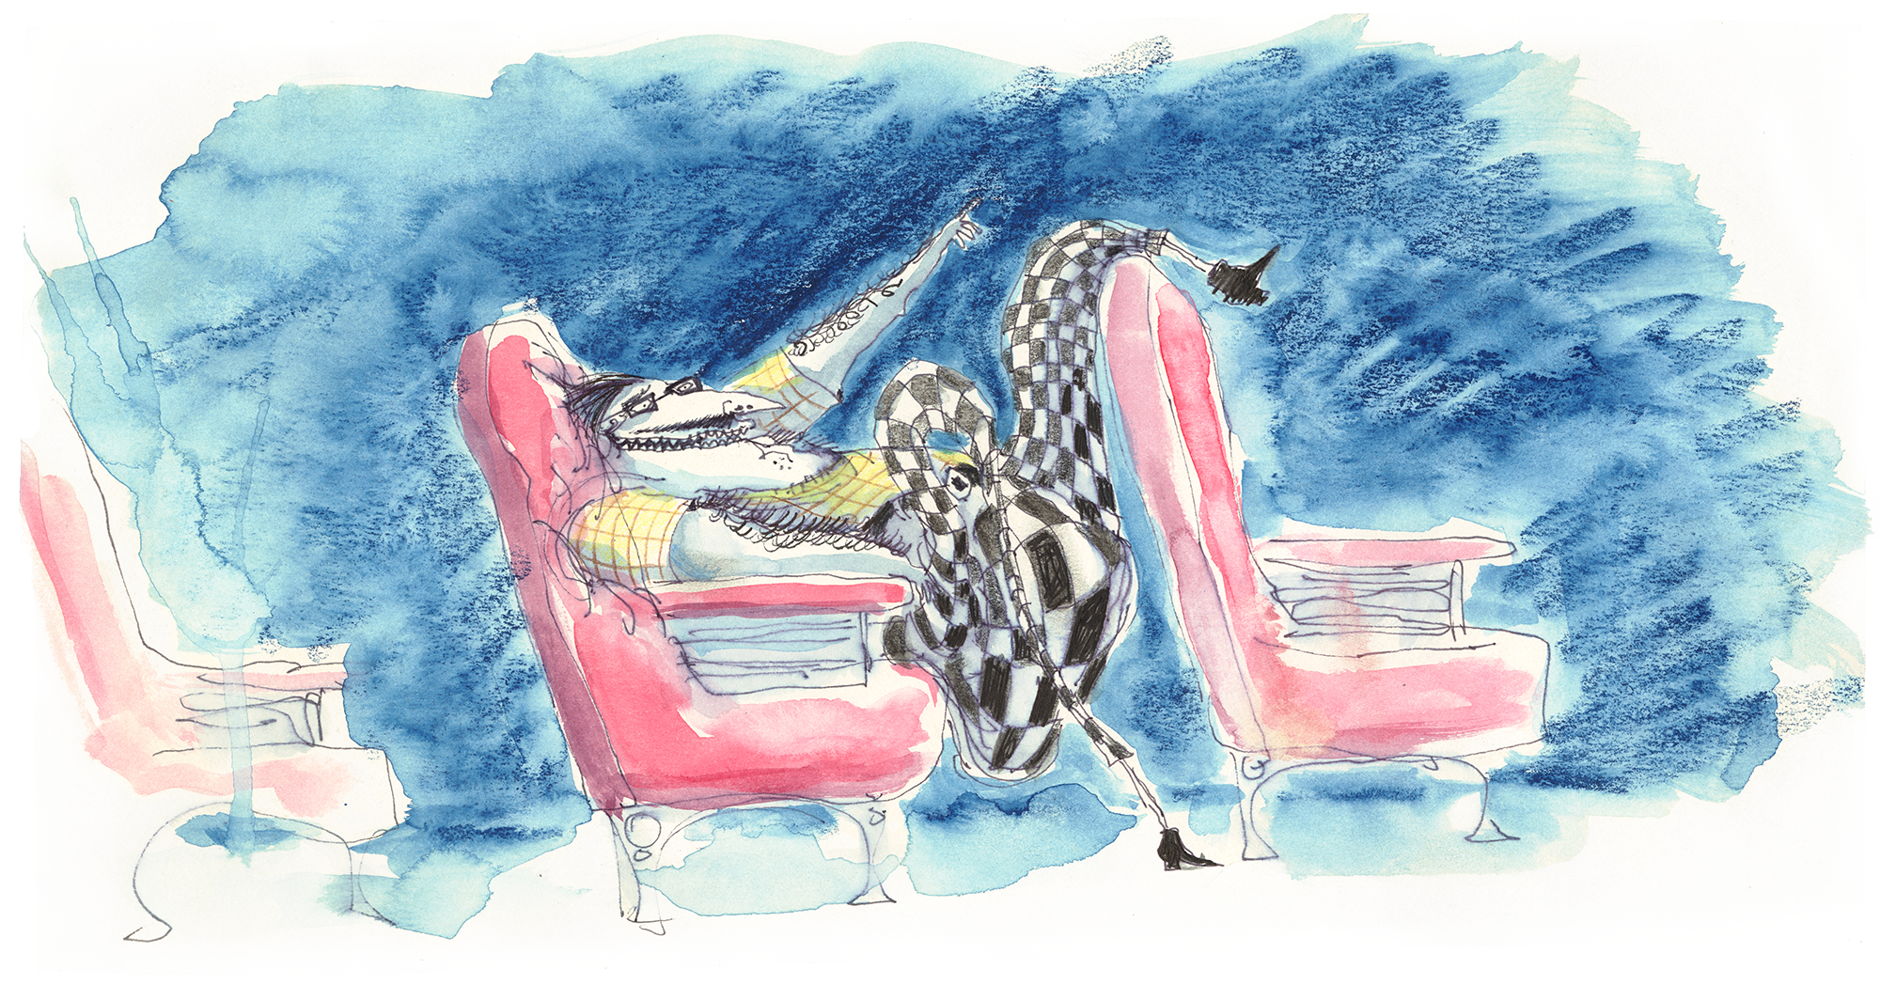

The World of Tim Burton
25 November 2024 – 21 April 2025 at the Design Museum

Tim Burton, born 1958, is an American film director known for his instantly recognisable worlds, rich with compelling outcasts and a distinct palette of colour and patterns.

Burton draws inspiration from a lifetime of voraciously watching TV and cinema, reading, sketching, consuming both culture ‘high’ and ‘low’ from the last century (and before). His eclectic tastes and strong design sensibility crystallise throughout his work into a singular, signature style. Canonised as ‘the Burtonesque’, this style comes to life in Burton’s films through long-term professional relationships with designers – across costume, production and set – who understand how to bring his vision to life on-screen.

‘the Burtonesque’: contrasts and collaboration
Suggested for KS2-3
Calling g a director an auteur (from the French ‘author’) essentially means that they – rather than a scriptwriter or any source material – are the dominant creative voice in their films. Auteurs often repeat visual, thematic, and/or narrative motifs to constitute a ‘signature style’.

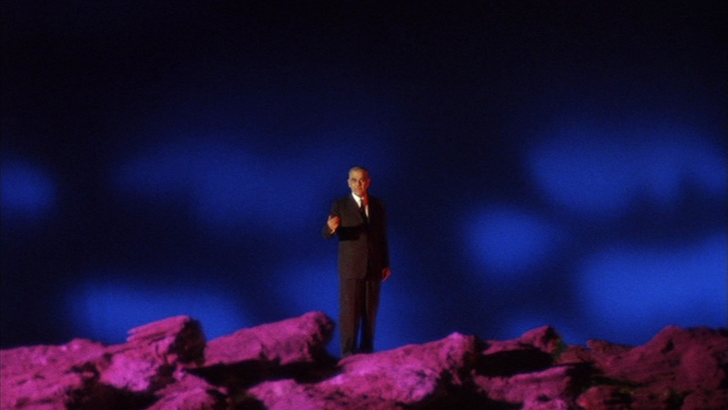
Still from Black Sabbath (1963), Mario Bava. Bava Became famous for his work in the italian ‘giallo’ genre, known for hyper-saturated colours, disorienting camera work, and lavish sets/costume. NB – not a genre appropriate to discuss in detail with younger students.

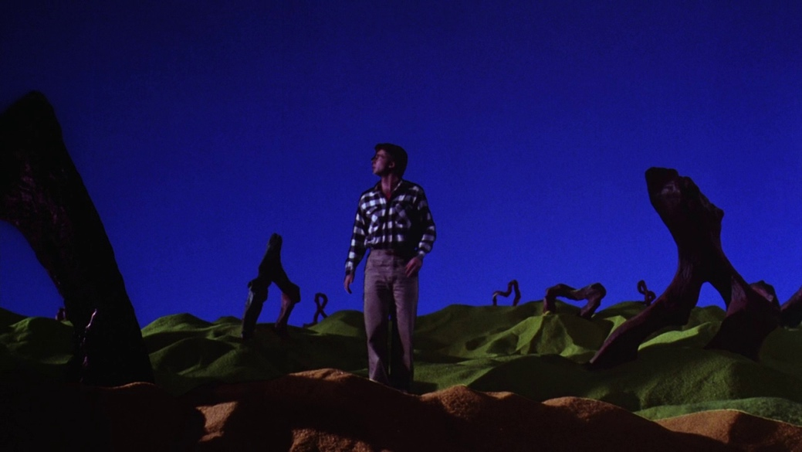
Still from Beetlejuice (1988), Tim Burton. The plaid shirt – a hallmark of American suburbia – is subverted to become a high-contrast block.

Some simple visual signifiers of the “Burtonesque” style are stripes, stitches, and cracks. The latter two often appear on the skin of so-called monsters, evoking Burton’s beloved Universal Frankenstein franchise as well as our own more metaphorical inner tensions. All these visual motifs tie into an overarching interest in precarity and juxtaposition, which Burton explores in similar ways to the directors he himself admires, such as Italian directors Federico Fellini and Mario Bava.

Colour, lighting, and composition can all heighten unease and thematic contrasts. Burton exaggerates colours as seen above in Beetlejuice, or often applies equally stylised desaturation, such as in Sweeney Todd (2007). His Corpse Bride (2005) alternates between both treatments of colour to (unexpectedly) differentiate the lands of the dead and the living.

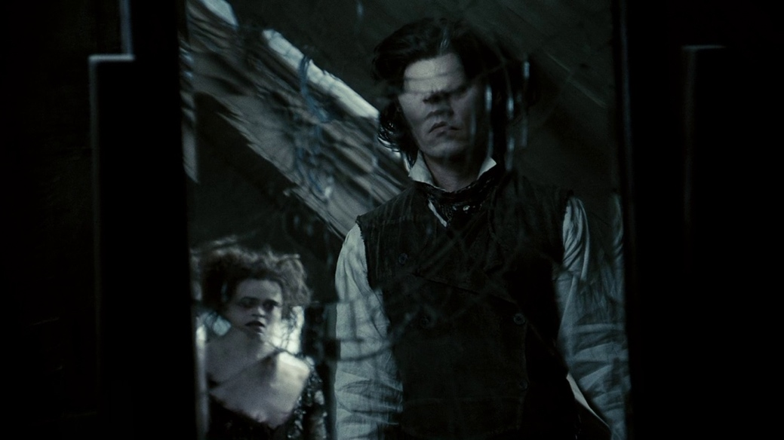
Cracks and desaturated colours in Sweeney Todd (2007), Tim Burton.

Burton often pays homage to the ‘B-movie’ horrors and late-night re-runs he grew up watching on his family’s TV set. Mars Attacks! (1996) humorously evokes “those 1950s [alien] invasion movies” (Burton, 2006): including Plan 9 from Outer Space (1957), directed by the so-called ‘Worst Director of All Time’, Ed Wood, who was the subject of Burton’s affectionate biopic Ed Wood (1994). In fact, he creates opportunities to work directly with formative 20th century film professionals, such as horror actors Vincent Price, Christopher Lee, and Michael Gough, and SFX makeup artists Rick Baker and Stan Winston. Mars Attacks! even features Polish New Wave director, Jerzy Skolimowski.

WORLD-BUILDING: SETS AND PRODUCTION DESIGN
Burton’s films convey a sense of a world beyond the screen. Other directors known for world-building include Ava DuVernay, Wes Anderson, Guillermo Del Toro, the Wachowski sisters, George Miller, and fellow animator Hayao Miyazaki. In each of their films, every detail is contextualised and built with utmost care. Often this involves trusted crew and partners.

Many of Burton’s collaborators are long-term professional partners with whom he has developed a “mutual understanding over time” (Burton quoted in Tim Burton: Designing Worlds. 2024) of how to build around his characters to “surround them in a setting they belong” (Burton, 1989. The Making of a Hero). Regular collaborators include production designers Bo Welch and Rick Heinrichs, and costume designer Colleen Atwood.

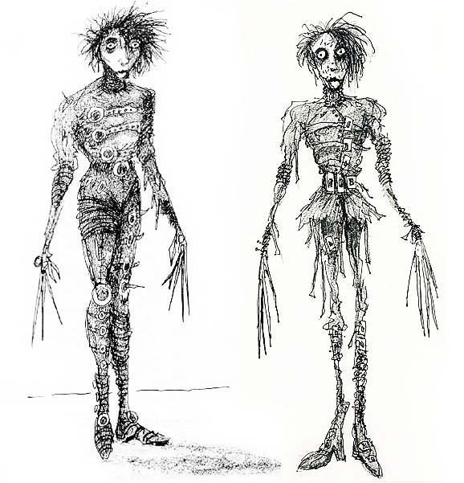 |  | 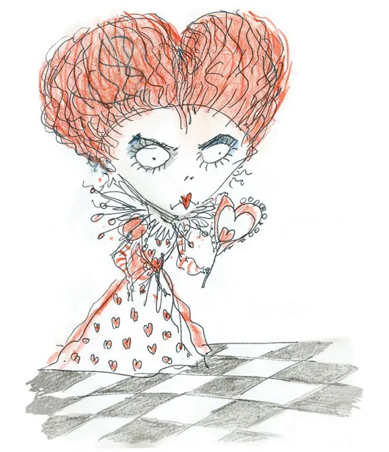
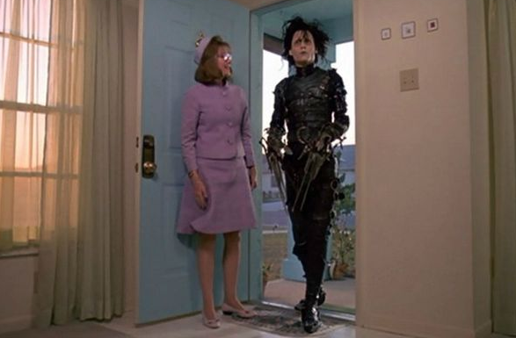 |  | 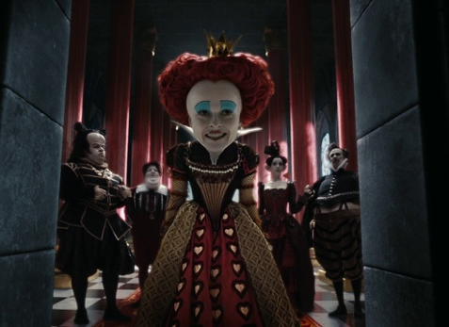
Burton’s initial concept sketches realised onscreen. LEft: Edward Scissorhands (1990), right: Alice in Wonderland (2010). Colleen atwood was costume designer for both films.

Through a process of iteration and collaboration, Burton’s worlds become as expressive as their inhabitants. CGI or animated backdrops may be more obviously manipulable, but films like Edward Scissorhands (1990) show that the medium of live-action is no obstacle to Burton’s vision. It was shot in a real suburban neighbourhood transformed into a heightened version of itself by the production crew, inspired by America’s post-war mass housing projects such as Levittown, New York. Its pastel tones were pulled from the American candy ‘Necco Wafers’, evoking both saccharine uniformity and “the memory of growing up in suburbia” (Burton quoted in Easton, 1990).

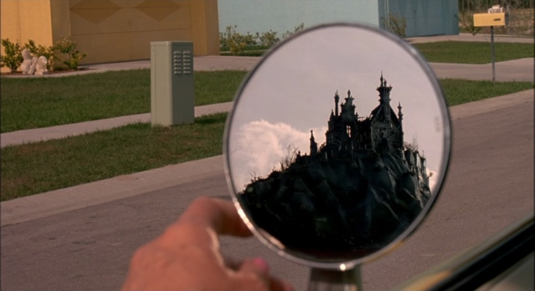  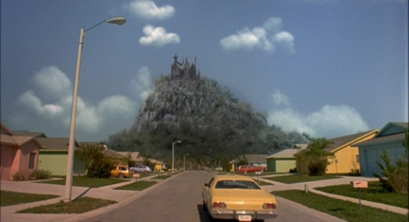 |  | 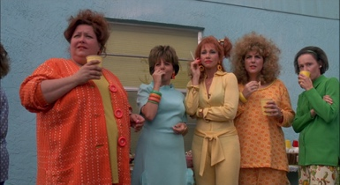  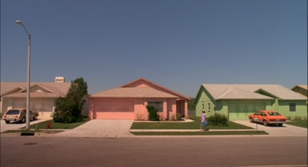  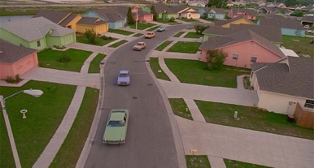
Stills from Edward Scissorhands (1990). costume design by Colleen atwood, production design by Bo welch. note Edward’s castle looming in the Left-hand imageS.

Edward’s castle was physically built near the shooting location, but shot separately before being composited together (sometimes very pointedly, as you can see in the images above). This was one of the only pieces of digital editing in the film, and was vital to provide Burton’s signature visual juxtaposition.

“The great thrill is the friction between those two aesthetics within a single frame.” – Burton’s regular production designer Bo Welch on Edward Scissorhands. Quoted in Chernov, 2015.

A very different approach to physical sets was taken for Batman (1989, Oscar-winning production design by Anton Furst) and Batman Returns (1992, by Bo Welch again). Inspired by German Expressionist cinema, a huge influence on Burton’s filmography, the city of Gotham was rendered using miniatures and painted backdrops (matte paintings).

These techniques date back to the early 20th century – notably Fritz Lang’s Metropolis , a clear visual inspiration for Burton’s Gotham – to render landscapes too large or otherworldly to be shot on location or built full-size. Footage could be composited with animation or even live-action actors in post-production using double-exposure, chroma keying (‘green screen’), or nowadays digitally.

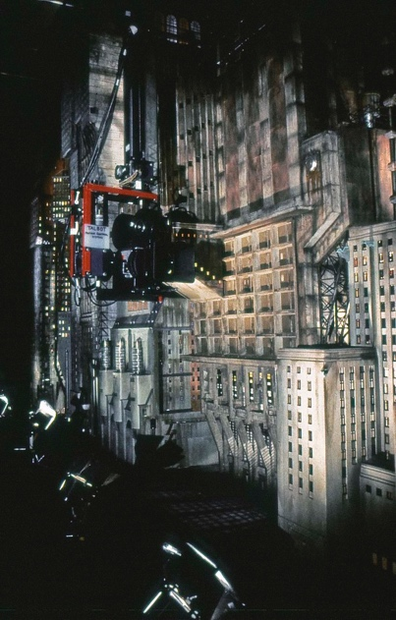 |  | 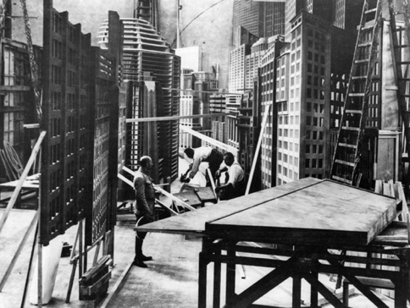
Batman (1989), Tim Burton. Production design: Anton furst. Murray Close © Warner Bros., The Guber-Peters Company, PolyGram Filmed Entertainment. |  | Metropolis (1927), Fritz lang. production design: otto Hunte, Erich Kettelhut and Karl Vollbrecht. Note the combination of 3D miniatures with 2d façades and matte paintings. Image courtesy of Deutsche Kinemathek.

Burton’s Batman franchise also pays homage to German Expressionism through cinematography, specifically its use of Dutch angles (a misleading corruption of ‘Deutsch’, or German, angle). The Dutch angle – meaning the camera is tilted at an angle to offset vertical lines, creating a sense of unease or danger – has been adopted by directors from Alfred Hitchcock to Spike Lee.

The Dutch angle became associated with the American film noir genre: mid-century Hollwood’s own interpretation of the German Expressionist influence, coloured by its post-Depression context of disillusionment and cynicism. The 1960s Adam West Batman TV show, known for its pastiche of the noir genre, often used Dutch angles to visually mark out villains as ‘crooked’ characters. Burton’s own application of the technique may have been inspired by the original German Expressionists, for the observant viewer it forges an unlikely match between Fritz Lang’s dystopia and the camp humour of West’s Batman which is typically ‘Burtonesque’.

Provocations
- Individually or in groups, make or plan (e.g. storyboard) a short film about a normal day or exploring a specific topic through your eyes.
- Stop-motion can be very accessible: use plasticene, paper cut-outs or objects around you.
- Build your own miniature world using everyday or waste materials: scrap paper and cardboard, pipe-cleaners, even food.
- Inspired by the Necco Wafers colours in Edward Scissorhands (1990), keep a sketchbook/scrapbook with you for a day or a week. In it, collect inspiration and notes as you go about your day for colours, designs, etc.
- Can you articulate what makes the images below (or any others you may select) ‘Burtonesque’?
- Analyse as photography, fashion, production design, and/or other.
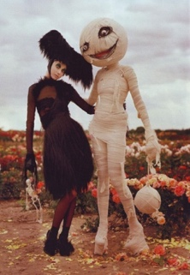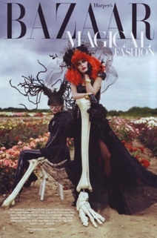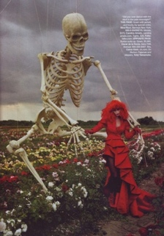 |  | Photoshoot for Harper’s Bazaar, October 2009. Images by Tim Walker (his second collaboration with Tim Burton).
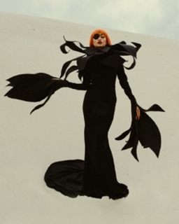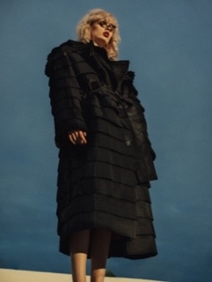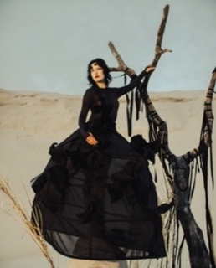 |  | Charles Vilmorin, Fall 2021 Couture. (Source and more images: WWD [Accessed August 2024]).
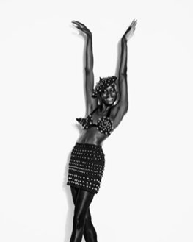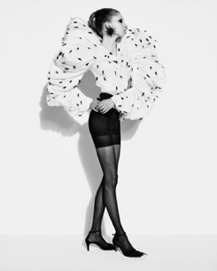 |  | Schiaparelli, Fall 2022 Ready-to-Wear. (Source and more images: WWD [Accessed August 2024]. NB – some partial nudity in linked images.)
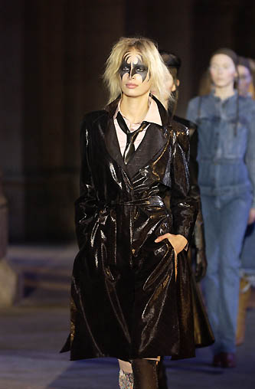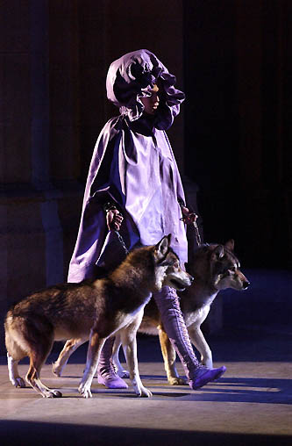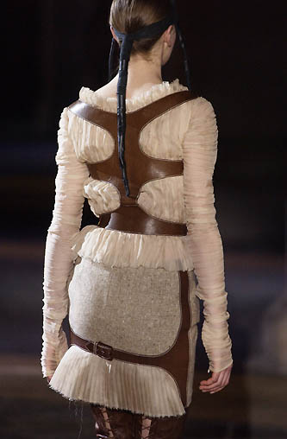 |  | Alexander McQueen Fall / Winter 2002 Ready to Wear. (Source and more images:  First View [Accessed August 2024]. NB – some partial nudity in linked images.)

What can designers learn from the director’s process?
Suggested for KS3-5
How do you think a film is made? Of course, it depends on the director; but filmmaking generally has several things in common with design which set both fields apart from most forms of art and creative practice. Directors need to work with and manage professional teams of actors, camera operators, set, prop, and costume designers, perhaps puppeteers or animators, and more. They need to account for practical and financial considerations alongside pure concept, narrative, and aesthetics. In fact, much of the director’s process can look very much like the designer’s process.

 |  | Design opportunity
 |  | A brief, user problem that needs solving, or gap in the market.
- A script or other existing text/story.
- Studio commission for a specific project.
 |  | Analysis and research
 |  | Break down the brief and target market, gather inspiration.
- Define/research target audience.
- Collect inspiration.
- Evaluate previous interpretations of the material.
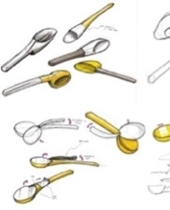 |  | Idea generation
 |  | Get all your ideas down on paper: try mind-maps, sketches.
- Collaborative ideation (e.g. Writers’ room).
- Sketching, scrapbooking.
- Initial storyboards.
 |  | Modelling, Testing, Evaluation
 |  | Select your best ideas to prototype, test, adjust and repeat.
- Auditions and ‘chemistry reads’.
- Miniature or partial props, sets, models.
- Rushes ('dailies').
- Test audiences.
 |  | Final design
 |  | Finalise your design and hand over to the manufacturer.
- Final models and concepts.
- Storyboards.
- ‘Sizzle reels’.
Final maquettes.

Images 2-5, showing development of S’up spoon, courtesy of Protolabs.

Focus: analysis and research
Tim Burton was part of the first generation to ‘grow up on television’, with an unprecedented level of access to visual media (an early inspiration for his lifelong sketching habit). He watched new and old horror features alongside hand-drawn animations by Disney and cartoonist Tex Avery on the family TV set. His consumption of both ‘high’ and ‘low’ culture extended beyond the television screen too: as a child he read Edgar Allan Poe alongside Dr Seuss. Burton’s worlds continue to draw on eclectic influences including German Expressionist and Italian giallo cinema, illustrator Edward Gorey, cartoons by Angelo Torres, Gahan Wilson and Henry Syverson, and the calaveras of José Guadalupe Posada.

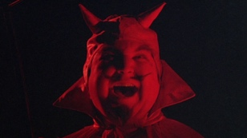 |  | 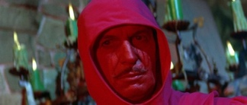  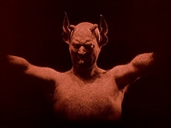
Left: Still from Burton’s first feature, Pee-Wee’s Big Adventure (1985). Possible inspirations – Middle: Still from Häxan (1922). Right: detail of vincent price in The Masque of the Red Death (1964), by iconic B-movie director Roger Corman and Based on a short story by Edgar Allan Poe.

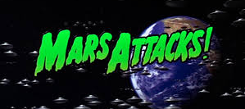 |  | 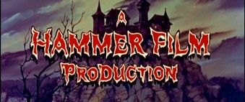
Left: OPening title for Mars attacks! (1996), Tim Burton. Right: Opening title for The brides of dracula (1960) by british production company hammer Film (best known for dracula (1958) starring christopher lee).

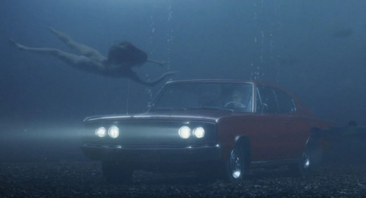 |  | 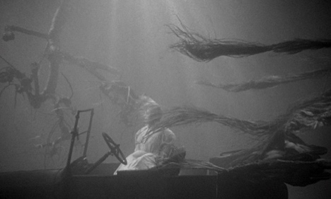
Left: Big fish (2003), Tim Burton. Right: the Night of the hunter (1955), charles laughton. The Night of the hunter was an initial flop, but 10 years later it became a cult favourite thanks to TV: “television took it to its heart … [and it] became a three-decade-long late-night broadcast booking.” (ravage, 1988). Several directors of burton’s generation mention having seen it as children, and name it as a lasting influence.

Focus: idea generation
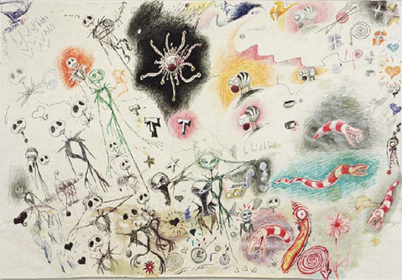 |  | 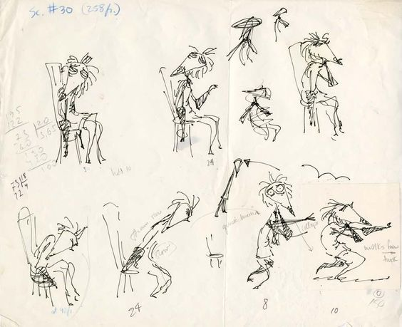
A sample of one of TIM BURTON’S many sketchpads. UNTITLED (DOODLE PAD SERIES) (C. 1989-1993). |  | Burton’s sketches for Vincent (1982) convey expressive movement even flat on Paper.

“Every time I do anything, I start with the character.”
– Tim Burton, 2006.
Tim Burton trained as a character animation designer at California Institute of the Arts (CalArts) after receiving a scholarship to study there. His strong command of visual language comes through clearly in his character designs. Animators often exaggerate bodies and faces in a way that suspends disbelief, but Burton extends this to live-action films through costume, SFX makeup, lighting, camera angles, and more recently CGI. These fantastical characters serve as the cornerstone of his world-building process.

At CalArts, Burton made a 98-second animated short, Stalk of the Celery Monster (1979), centring the mad scientist trope popularised by German Expressionist film The Cabinet of Dr Caligari (1920). German Expressionism influences much of Burton’s work, particularly his Batman films: the character design for the Joker in Batman (1989) is directly modelled on The Man Who Laughs (1928), and the Penguin in Batman Returns (1992) strongly resembles Dr Caligari himself.

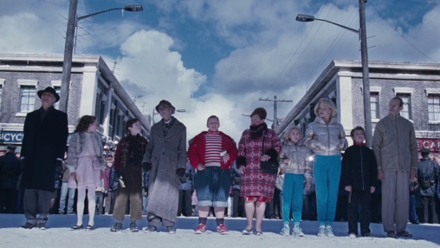 |  | 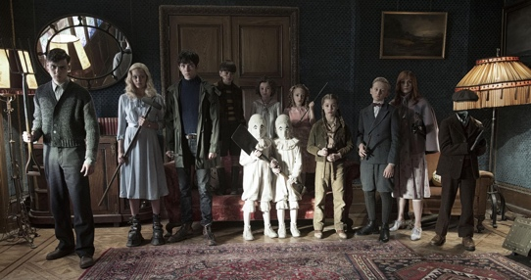
Left: charlie and the chocolate factory (2005). Right: miss peregrine’s home for peculiar children (2016). Even in live-action, burton’s keen understanding of shape and colour fill his character designs.

FOCUS: MODELLING, TESTING, EVALUATION
Films (usually) convey a physical world, and animators in particular need to be conscious of depth, texture, weight, squash and stretch, abiding by some kind of physics even if those of a fantasy world.

As a child Burton watched Ray Harryhausen films at the cinema. Harryhausen pioneered a form of hybrid animation through which a model could appear to be interacting with live-action entities and sets, and inspired the young Burton to film his own stop-motion shorts. Today, animators still use similar stationary model maquettes to help refine and communicate 3D character designs.

Hand-drawn animators often sketch from real life, and may act out actions or expressions in a mirror to evaluate their work and its ‘believability’. Stop-motion already exists in the physical world, but this brings its own challenges: puppets need to be proportionate to one other and their sets, manipulable (down to the minutiae of facial expressions and gestures) but not flimsy. Joints and armatures are often prototyped before building the final articulated puppet.
“The eventual goal is to create a puppet that is fully articulated for the animators, while remaining true to Tim’s original sketches.”
– Ian Mackinnon, of regular Burton collaborators Mackinnon & Saunders. (2024. The World of Tim Burton.)

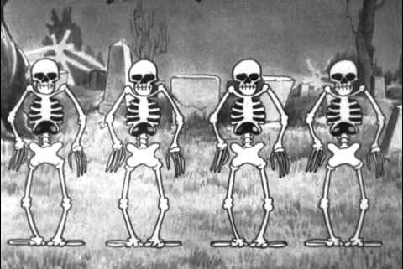 |  | 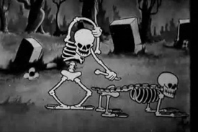
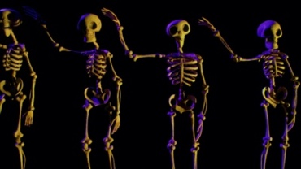 |  | 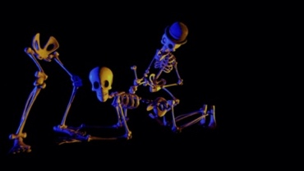
parallels between Disney’s hand-drawn Silly Symphonies – the Skeleton Dance (1929 – top) and Tim Burton’s stop-motion Corpse Bride (2005 – bottom). hand-drawn animation released filmmakers from the vice-grip of a static camera and physical world, and arguably laid the groundwork for today’s computer SFX.

Provocations
- What is the earliest creative influence you can remember in your life that is present in your ideas or tastes today? Why do you think it’s stuck with you?
- Can you think of another ‘auteur’ and find examples of their influence outside cinema?
- Consider character designs in films you have seen. Try to draw just their shapes or silhouettes, or list dominant colours. Do you notice any patterns or surprises? (This is easier with animated films, but try it with live-action for a challenge).
- Try writing a poem (perhaps emulating Dr. Seuss or Edgar Allen Poe, two Burton favourites). Who would be the perfect voice to read it out? How might you render it in a visual form?

Further reading. All online sources accessed August 2024.
Council for the Curriculum, Examinations & Assessment (no date) Advanced Portfolio – Practitioner Study Animator: Ray Harryhausen [Internet download – Factfile for GCE A2 Level Moving Image Arts]. Belfast, CCEA. Available free from CCEA – direct download link.
Determan, S. BFI (2021). The many merry eras of Disney [Internet]. Available https://www.bfi.org.uk/features/many-merry-eras-disney.
Back-issues of Cinefantastique magazine are available online from https://archive.org/download/cinefantastique_1970-2002. Recommended issues below: Clarke, F. ed. (1989). Cinefantastique, 20 (1-2) [Print magazine], November 1989 [PDF for this issue accessed August 2024 – link].
- Clarke, F. ‘Introduction’, p.2.
- Jones, A. ‘BATMAN’, pp.48-63
- White, T. L. ‘The Making of Tim Burton’s Beetlejuice & His Other Bizarre Gems’, pp.64-85.
Clarke, F. ed. (1994). Cinefantastique, 25 (5) [Print magazine], October 1994 [PDF for this issue accessed August 2024 – link].
- Jones, A. ‘Tim Burton’s “Edward Scissorhands”: Burton’s first fairytale”’, pp.12-19.
- Carducci, M. ‘Ed Wood, Cult Legend: fact vs. Tim Burton’s fiction’, pp.21, 23.
- French, L. ‘Tim Burton’s Ed Wood: a meeting of minds’, pp.32-34.
Finn, P. (no date) ‘Urban Dystopia: The Architecture of Gotham City.’ Architizer [Internet]. Available https://architizer.com/blog/practice/details/gotham-city-in-cinema-an-exploration-in-urban-dystopia/.
Heaney, C. (2021) ‘Ray Harryhausen: The man who brought myths to life.’ Art Fund_ [Internet]. Available https://www.artfund.org/explore/get-inspired/features/ray-harryhausen-the-man-who-brought-myths-to-life
Heinrichs, R. (2013) Interviewed by: Edwards, R. ‘Frankenweenie: Production Designer Interview.’ Games Radar [Internet]. Available https://www.gamesradar.com/frankenweenie-production-designer-interview/.
Kring-Schreifels, J. (2020) ‘How They Made It: The Pastel Suburbs of ‘Edward Scissorhands’.’ The Ringer [Internet]. Available https://www.theringer.com/movies/2020/12/14/22173289/edward-scissorhands-neighborhood-florida-how-they-made-it.
New York Film Academy (2023). ‘The History of Animation: Celebrating Disney’s 100 Years of Stories’ [Internet]. Available https://www.nyfa.edu/student-resources/quick-history-animation/.
Rennie, D. (2020) ‘Inside the mind of Anton Furst: the man who put the ‘Gothic’ into Gotham City.’ Bold Entrance [Internet]. Available https://boldentrance.com/inside-the-mind-of-anton-furst-the-man-who-put-the-gothic-into-gotham-city/.
Rúben Dias (2015) ‘Tim Burton: A German Expressionist Influence’ [Internet video]. Available https://vimeo.com/130795708
Sony Pictures Home Entertainment. ‘Tim Burton sits down with Ray Harryhausen’. Special feature from 20 Million Miles to Earth (2007). [DVD] Available https://www.youtube.com/watch?v=uMLMi-zQvL4.
Stoddard, C. (2011) ‘A Brief Exploration of Tim Burton's Special Effects.’ Quail Bell Magazine [Internet]. Available http://www.quailbellmagazine.com/the-real/a-brief-exploration-of-tim-burtons-special-effects.
Tasker, A. (2022) ‘Ray Harryhausen Talks About His Cinematic Magic.’ American Cinematographer, The American Society of Cinematographers [Internet]. Available https://theasc.com/articles/ray-harryhausen-talks-about-his-cinematic-magic.
Vox (2021) Why movies tilt the camera like this [Internet video]. Available from https://www.youtube.com/watch?v=SHYfsYQDr6M.
@PandaSagoma and @CookieNomie. Fantasy Creature Generator on Perchance.org. Available https://perchance.org/fantasy-creature-generator.

Bibliography. All online sources accessed [month year].
Batman: The Making of a Hero (1989) [Promotional TV Special]. Mindseye Films. Available https://youtu.be/GznnwEJxEos.
Burton, T., and Salisbury, M. ed. (2006). Burton on Burton. Rev. ed. London, Faber and Faber.
McLintock, M. ed. (2024). Tim Burton: Designing Worlds. London, The Design Museum.
Chernov, M. (2015) ‘Edward Scissorhands’: From Box Office Misfire to Cinema Classic. Variety [Internet]. 7 December, 2015. Available https://variety.com/2015/film/news/edward-scissorhands-25th-anniversary-johnny-depp-tim-burton-1201653236/.
Easton, N. J. (1990) For Tim Burton, This One’s Personal: The director of ‘Beetlejuice’ and ‘Batman’ is filming another bizarre movie – but this tale draws on his own childhood images. Los Angeles Times. 12 August, 1990. Available https://www.latimes.com/archives/la-xpm-1990-08-12-ca-1092-story.html.

Referenced films, shorts, and TV (in chronological order).
The Cabinet of Dr Caligari. (1920) [Film] Directed by Robert Wiene. Berlin, Decla-Film.
- Available on Kanopy through public libraries, https://www.kanopy.com/en/product/cabinet-dr-caligari.
Häxan. (1922) [Film] Directed by Benjamin Christensen. Stockholm, SF Studios (formerly Svensk Filmindustri). Distributed: New York, NY, Janus Films.
- Available on Kanopy through public libraries https://www.kanopy.com/en/product/haxan.
Metropolis. (1927) [Film] Directed by Fritz Lang. Potsdam, UFA GmbH (formerly Universum-Film Aktiengesellschaft). Distributed: Hollywood, CA, Paramount Pictures.
- Available on Kanopy through public libraries https://www.kanopy.com/en/product/metropolis-0.
The Man Who Laughs. (1928) [Film] Directed by Paul Leni. Hollywood, CA, Universal Pictures.
The Skeleton Dance (1929) Silly Symphonies. US, Walt Disney Animation Studios, June 1929.
- Available https://youtu.be/vOGhAV-84iI.
Black Sabbath. (1963) [Film] Directed by Mario Bava. Beverley Hills, CA, American International Pictures; Italy, Galatea Film; France, Societé Cinématographique Lyre.
The Masque of the Red Death. (1964) [Film] Directed by Roger Corman. England, Alta Vista Productions.
Stalk of the Celery Monster. (1979) [Short film – student project] Directed by Tim Burton. Hollywood, CA, California Institute of the Arts.
Vincent. (1982) [Short film] Directed by Tim Burton. Hollywood, CA, Walt Disney Productions.
- Available https://www.youtube.com/watch?v=0owXeJbhdvY
Pee-Wee’s Big Adventure. (1985) [Film] Directed by Tim Burton. Hollywood, CA, Warner Bros. Pictures.
Batman. (1989) [Film] Directed by Tim Burton. Hollywood, CA, Warner Bros. Pictures.
Batman Returns. (1992) [Film] Directed by Tim Burton. Hollywood, CA, Warner Bros. Pictures.
Edward Scissorhands. (1990) [Film] Directed by Tim Burton. Hollywood, CA, Twentieth Century Fox.
Corpse Bride. (2005) [Film] Direced by Tim Burton. Hollywood, CA, Tim Burton Productions; Hillsboro, OR, LAIKA, LLC.
Alice in Wonderland. (2010) [Film] Directed by Tim Burton. Hollywood, CA, Walt Disney Studios Motion Pictures

the Design Museum Learning team
E: learning@designmuseum.org

the Design Museum, 224-238 Kensington High Street, London W8 6AG
The Design Museum is a multifaceted museum, an ever-changing space for the public, industry and education to come together and explore new ideas.

designmuseum.org
@designmuseum



