Tim Burton exhibition drives biggest advance ticket sales in Design Museum’s history
The World of Tim Burton
25 October 2024 – 21 April 2025
the Design Museum
In partnership with Harvey Nichols
PRESS IMAGES AVAILABLE
- The World of Tim Burton exhibition opens on Friday with the Design Museum’s biggest ever ticket pre-sales
- Tim Burton visits the exhibition today to inaugurate the show in his adopted home city
- 600 items from Burton’s fifty years of creative output can be seen from Friday, including hundreds of artworks of his much-loved characters from his personal archive
- Catwoman suit and Wednesday Addams’ viral Rave’N dance dress among costume highlights
The Design Museum today reveals that its major exhibition on the exceptional career of director Tim Burton has smashed the museum’s record for advance ticket sales.

Over 32,000 people have already snapped up their tickets to The World of Tim Burton exhibition — opening on Friday — making it the biggest advance ticket sales for an exhibition in the Design Museum’s 35-year history.

The news is announced on the day Tim Burton officially inaugurates the exhibition at the Design Museum ahead of Friday’s public opening. Tim Burton visited the exhibition today and posed for photographs, marking the final stop of his personal archive touring the world. It’s the first and only time his archives have been seen in the UK.

Tim Marlow, Director and CEO of the Design Museum, said: “We’re obviously delighted that our landmark Tim Burton exhibition has already generated cinematic blockbuster levels of interest and excitement before it has even opened. It’s a real testament to Tim Burton’s impact on the creative world that his exhibition has driven the biggest pre-sales in our history, by quite some way. We can’t wait for everyone to step inside the World of Tim Burton from Friday.”

Tim Burton says: “It’s a strange thing, to put 50 years of art and your life on view for everyone to see, especially when that was never the original purpose. In the past, I have resisted having the exhibition in London, however, collaborating with the Design Museum for this final stop was the right choice. They understand the art, and with the opportunity to adapt the show and highlight the way design interacts with the works, I’ve been able to view it all through an exciting new lens.”
The exhibition will run until 21 April 2025. Due to demand, it will be open late on Friday and Saturday evenings for the rest of 2024. Design Museum members will be able to visit the show for free, without the need to prebook.

The World of Tim Burton exhibition

Visitors are invited to step into The World of Tim Burton from 25 October, to journey through five remarkable decades of creativity, and to see the famed and fascinating objects from Tim Burton’s earliest unrealized projects to his most recent film, Beetlejuice Beetlejuice (2024).

Over 600 incredible items have been brought together in the exhibition to chart the evolution of Burton’s unique design aesthetic. Objects are loaned from Tim Burton’s extensive personal archives, key film studio archives including Paramount, Amazon MGM Studios, and Warner Bros., and the private collections of Burton’s collaborators. Many items have never been on public display in the UK before.

Highlights include hundreds of Burton’s expressionistic sketches and drawings that he has created prolifically since childhood. These are seen alongside props, set designs, and costumes from his iconic films, including Michelle Pfeiffer’s Catwoman costume from 1992’s Batman Returns and the black and white striped dress from 1999’s Sleepy Hollow, worn by Christina Ricci.

The World of Tim Burton — which opens just in time for Halloween — showcases Burton’s remarkable output, with over 18 of his films individually spotlighted in the exhibition. It celebrates the creative processes behind some of the most significant movies of the past five decades, including Beetlejuice (1988), Batman (1989), Edward Scissorhands (1990), and Charlie and the Chocolate Factory (2005).

The exhibition comes to London after a hugely successful decade-long world tour that has seen it visit 14 cities in 11 countries since 2014. Yet not only is this the first and only time it will be seen in the UK, it is also be the very final time the exhibition will be staged.

For this very special homecoming — to Tim Burton’s adopted home city — it has been specially adapted, expanded, and physically reimagined for the Design Museum.

Visitors will for the first time be able to take a deeper look at the director's work by seeing it through a design lens. With the addition of over 90 new objects to the exhibition, this iteration of the show examines Burton’s hands-on and design-led approach to filmmaking.

A major new aspect is also the spotlighting of his long-term collaborations with designers working across costume, set and production design. This includes the renowned costume designer Colleen Atwood, production designer Rick Heinrichs, architect and designer Anton Furst, and the award-winning puppet makers and stop-motion animators Mackinnon and Saunders.

The exhibition’s narrative has also been fully reimagined for the Design Museum.

Visitors will begin in ‘Suburban Beginnings’, charting Burton’s early artistic endeavours, his studies at college, and his time working as an apprentice animator at Disney. Visitors will then move from the Hollywood suburb to the Hollywood Studio and into ‘Crafting Imagination’, exploring his immense contributions to stop-motion animation and those themes which have influenced his work, like festive holidays and the 'Carnivalesque'.

‘Building Worlds’ celebrates thirteen key feature films and the television series Wednesday through the lens of design, while the section ‘Drawing Narratives’ displays a volume of artwork that illustrate Burton’s prolific output as an artist and visual storyteller.

Finally, ‘Beyond Film’ moves from the world of Tim Burton to the universe, exploring projects he has produced outside of cinema, like books and music videos, and designers who have been inspired by the Burtonesque, such as photographer Tim Walker.

The exhibition immerses visitors into specific landscapes reminiscent of his filmography — from the suburbs to angular corridors and film soundstages –– all accompanied by a custom soundscape created especially for the Design Museum by sound designer Tomi Rose.

Exhibition highlights
At the exhibition’s core are hundreds of Tim Burton’s expressionistic sketches and drawings that he has prolifically produced since childhood. These works depict everything from individual characters to whole environments and are always the first step in Burton’s creative process to build the fantastical worlds in each of his films.

Visitors will see some of the earliest incarnations of much-loved and recognised characters such as the Martians from Mars Attacks! (1996), the Mad Hatter from Alice in Wonderland (2010), Emily in Tim Burton's Corpse Bride (2005), and many other famous eye-catching figures. Nearly all of these drawings are making their first ever public display in the UK.

The original artworks can be seen directly alongside costumes, props, and set pieces from the movies they ultimately featured in, charting the journey characters and worlds have taken from Burton’s imagination to cinematic reality. This includes Colleen Atwood’s instantly-recognisable costume for Edward Scissorhands — as worn by actor Johnny Depp in the 1990 film — which is seen with Bo Welch's set design models for the movie, Stan Winston’s infamous scissor hands, and seven of Burton’s earliest sketches of the character.

Another iconic costume added to the exhibition for the first time for this final London staging is Catwoman’s rubber and latex suit from 1992’s Batman Returns, featuring the stitched motif that Burton repeatedly returns to throughout his works.

There is also the first ever public display of the Rave’N dance dress worn by actor Jenna Ortega in character as Wednesday Addams in the Netflix series produced by MGM Television which debuted in 2022. The school uniform for the series, designed by Atwood, is also shown, paired alongside Burton’s original character concept drawings.

Visitors will additionally be able to see a recreation of the private studio where Tim Burton works, giving a rare private glimpse into his creative process. The walls of this installation are lined with illustrations from recent projects, including designs for a 65m high mural depicting an epic battle between a robot and a monster that was installed in São Paulo, Brazil.

The exhibition’s finale is a brand new specially created cinema experience. A major newly-commissioned film gives voice to some of Burton’s key collaborators, and will be shown in a bespoke art-deco space reminiscent of the theatres Tim Burton would frequent as a child growing up in Hollywood.

Maria McLintock, curator of The World of Tim Burton at the Design Museum, says: “For Tim Burton, each film begins with a drawing, that he often returns to over time, almost like old friends. We’re thrilled to be displaying so many of these deeply personal works at the Design Museum, in the heart of the city he’s called home for over twenty years. This hugely successful show has delighted audiences across the globe for over a decade, but our Design Museum reimagining, with many new additions and new narratives, means this is an unprecedented opportunity to be immersed in Tim Burton’s unique and singular vision.”

To accompany the exhibition, the Design Museum also publishes a brand-new in-depth book Tim Burton: Designing Worlds. This is the first publication to explore the relationship between Tim Burton’s cinematic creations and the world of design. Featuring an exclusive new interview with Burton, essays by Imogen West-Knights and Ryan White, and interviews with collaborators like Colleen Atwood and Mackinnon & Saunders, the book is available now.
The Design Museum and Snap Inc also release today a free AR Experience honouring Tim Burton's creativity and which can be used to explore a space-themed Burtonian fantasy using your phone.

Ben Wymer, Director of Global Brand Experience at Snapchat said: “We are very excited to be adding an extra layer to the Design Museum’s exhibition by bringing the legendary work of Tim Burton to life through Snapchat’s AR technology - immersing fans like never before in Burton’s universe and characters inside the museum’s atrium.
“This collaboration is the latest initiative from Snapchat’s AR Studio in a line up of creative projects with renowned art and design institutions from around the world. Our ongoing partnership with the Design Museum is a brilliant celebration of the important role Snapchat plays in the way people engage with and experience arts and culture in 2024.”

“We encourage exhibition visitors to explore ‘The World of Tim Burton’ Lens on Snapchat and witness the magic unfold!”

The exhibition is organized by Jenny He, Independent Curator, in collaboration with Tim Burton and adapted by Maria McLintock for the Design Museum.

The World of Tim Burton is presented in partnership with Harvey Nichols. To celebrate the exhibition and its new partnership with the Design Museum, Harvey Nichols will unveil a Burtonesque Christmas window display later this year. It will feature five unique objects from Tim Burton’s private collection, previously showcased in his exhibitions around the globe.

-Ends-

Notes to Editors

PRESS ENQUIRIES:
Maxwell Blowfield, Senior Media and PR Manager
E: maxwell.blowfield@designmuseum.org

Press Office
E: pr@designmuseum.org

About the Design Museum:
The Design Museum is a multifaceted museum, an ever-changing space for the public, industry and education to come together and explore new ideas. A registered charity, the museum's innovative exhibitions, partnerships, research and learning programmes evidence how design can enable this planet and its inhabitants to thrive. Our landmark building in Kensington is the centre of our national network and a global hub for the transformative potential of design.

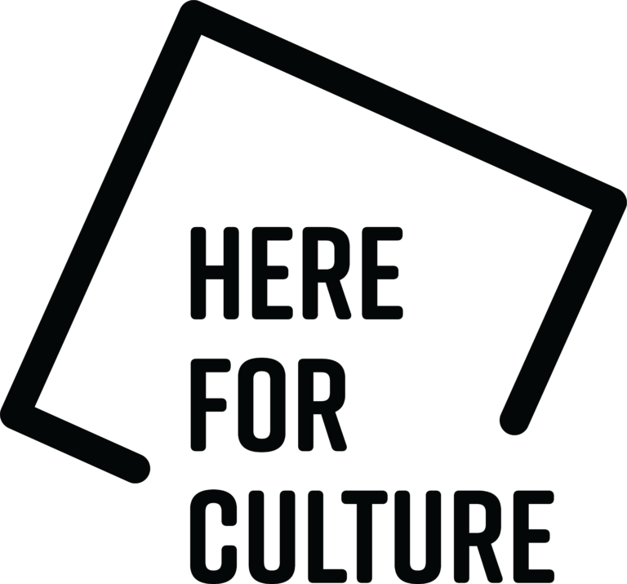

designmuseum.org
@designmuseum

About Harvey Nichols
Founded in 1831, Harvey Nichols is one of the world’s leading luxury retailers, renowned for its exclusive edit of the most prestigious brands across Women’s, Men’s & Kid’s Fashion, Beauty & Beauty Services, Food, Wine & Hospitality.

About Snap Inc. AR Experience
Immerse yourself in a digital dome inspired by Burton's unique illustrations. When you visit the museum, discover a mesmerising free AR experience created by Snapchat’s Paris AR Studio honouring Tim Burton's creativity. From the museum’s atrium, explore a space-themed Burtonian fantasy using your phone. Please note that this is a free experience open to all visitors, and no pre-booking is needed. To see The World of Tim Burton exhibition, you will need to book a ticket.

With thanks to Snap Inc.



